**Gráfica de Gantt**

|  |  |  |  |
| --- | --- | --- | --- |
| Actividad | | Fecha de inicio | Fecha fin |
| Obtención de requerimientos | A | 08-08-16 | 15-08-16 |
| Definición de requerimientos del vendedor | B | 16-08-16 | 29-08-16 |
| Definición de requerimientos del comprador | C | 16-08-16 | 29-08-16 |
| Diseño base de datos del vendedor | D | 29-08-16 | 19-09-16 |
| Diseño base de datos del comprador | E | 29-08-16 | 19-09-16 |
| Diseño de la arquitectura de la aplicación | F | 29-08-16 | 19-09-16 |
| Diseño interfaz | G | 29-08-16 | 19-09-16 |
| Construcción de la base de datos | H | 19-09-16 | 31-10-16 |
| Construcción de la aplicación | I | 19-09-16 | 31-10-16 |
| Demostración | J | 01-11-16 | 08-11-16 |
| Mejoras de estabilidad | K | 08-11-16 | 25-11-16 |
| Mejoras de rendimiento | L | 08-11-16 | 25-11-16 |
| Pruebas | M | 28-11-16 | 09-12-16 |
| Implementación | N | 12-12-16 | 21-12-16 |

**Matriz de precedencia**

|  |  |  |
| --- | --- | --- |
| Actividad | Predecesores | Duración |
| A | - | 7 |
| B | A | 13 |
| C | A | 13 |
| D | B | 21 |
| E | C | 21 |
| F | B-C | 21 |
| G | B-C | 21 |
| H | D-E | 42 |
| I | F-G | 42 |
| J | H-I | 7 |
| K | J | 17 |
| L | J | 17 |
| M | K-L | 11 |
| N | M | 9 |

**PERT Simple**

|  |  |  |  |  |  |  |  |
| --- | --- | --- | --- | --- | --- | --- | --- |
| Act. | Duración | TIP | TTP | TIL | TTL | HT | HL |
| AB | 7 | 0 | 7 | 0 | 7 | 0 | 0 |
| AC | 7 | 0 | 7 | 0 | 7 | 0 | 0 |
| BD | 13 | 7 | 20 | 7 | 20 | 0 | 0 |
| BP | 0 | 7 | 7 | 7 | 7 | 0 | 0 |
| CE | 13 | 7 | 20 | 7 | 20 | 0 | 0 |
| CP | 0 | 7 | 7 | 7 | 7 | 0 | 0 |
| DH | 21 | 20 | 41 | 20 | 41 | 0 | 0 |
| EH | 21 | 20 | 41 | 20 | 41 | 0 | 0 |
| PF | 13 | 7 | 20 | 7 | 20 | 0 | 0 |
| PG | 13 | 7 | 20 | 7 | 20 | 0 | 0 |
| FI | 21 | 20 | 41 | 20 | 41 | 0 | 0 |
| GI | 21 | 20 | 41 | 20 | 41 | 0 | 0 |
| HJ | 42 | 41 | 83 | 41 | 83 | 0 | 0 |
| IJ | 42 | 41 | 83 | 41 | 83 | 0 | 0 |
| JK | 7 | 83 | 90 | 83 | 90 | 0 | 0 |
| JL | 7 | 83 | 90 | 83 | 90 | 0 | 0 |
| KM | 17 | 90 | 107 | 90 | 107 | 0 | 0 |
| LM | 17 | 90 | 107 | 90 | 107 | 0 | 0 |
| MN | 11 | 107 | 118 | 107 | 118 | 0 | 0 |
| NO | 9 | 118 | 127 | 118 | 127 | 0 | 0 |

Rc= 127 días

**PERT Probabilístico**

|  |  |  |  |  |  |
| --- | --- | --- | --- | --- | --- |
| Act. | a | m | b | te | var |
| AB | 5 | 7 | 8 | 6.8 | 0.25 |
| AC | 5 | 7 | 8 | 6.8 | 0.25 |
| BD | 10 | 13 | 14 | 12.6 | 0.44 |
| BP | 0 | 0 | 0 | 0 | 0 |
| CE | 10 | 13 | 14 | 12.6 | 0.44 |
| CP | 0 | 0 | 0 | 0 | 0 |
| DH | 16 | 21 | 23 | 20.5 | 1.36 |
| EH | 17 | 21 | 24 | 20.8 | 1.36 |
| PF | 10 | 13 | 14 | 12.6 | 0.44 |
| PG | 10 | 13 | 14 | 12.6 | 0.44 |
| FI | 18 | 21 | 23 | 20.8 | 0.69 |
| GI | 15 | 21 | 22 | 20.1 | 1.36 |
| HJ | 35 | 42 | 43 | 41 | 1.77 |
| IJ | 40 | 42 | 45 | 42.1 | 0.69 |
| JK | 5 | 7 | 8 | 6.8 | 0.25 |
| JL | 5 | 7 | 8 | 6.8 | 0.25 |
| KM | 14 | 17 | 18 | 16.6 | 0.44 |
| LM | 13 | 17 | 18 | 16.5 | 0.69 |
| MN | 9 | 11 | 13 | 11 | 0.44 |
| NO | 8 | 9 | 11 | 9.1 | 0.25 |

|  |  |  |
| --- | --- | --- |
| Evento | Ruta más larga | Valor esperado |
| A | - | - |
| B | AB | 6.8 |
| C | AC | 6.8 |
| D | ABD | 19.4 |
| E | ACE | 19.4 |
| F | ABPF / ACPF | 19.4 |
| G | ABPG / ACPG | 19.4 |
| H | ACEH | 40.2 |
| I | ABPFI | 40.2 |
| J | ABPFIJ | 82.3 |
| K | ABPFIJK | 89.1 |
| L | ABPFIJL | 89.1 |
| M | ABPFIJKM | 105.7 |
| N | ABPFIJKMN | 116.7 |
| O | ABPFIJKMNO | 125.8 |

Rc= 125.8 días

**Red PERT**

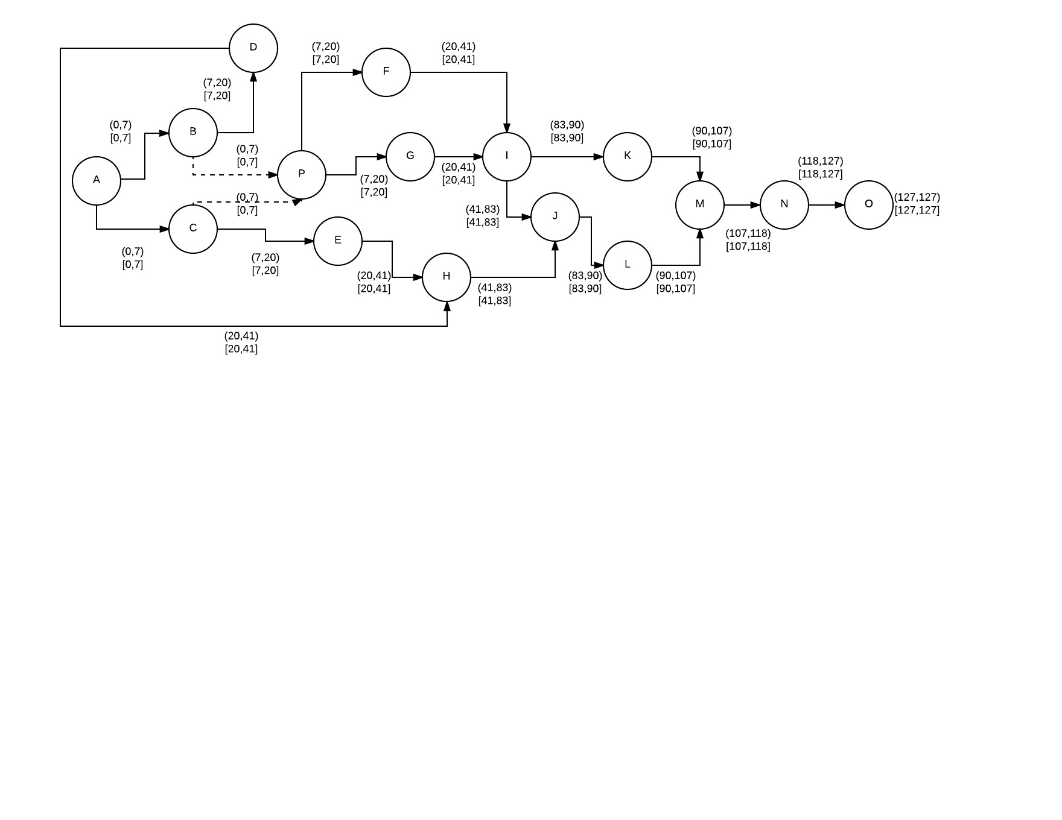

PERT - COSTO

|  |  |  |  |  |  |
| --- | --- | --- | --- | --- | --- |
|  | NORMAL | | INTENSIVO | |  |
| Actividad | T(dias) | Costo(pesos mexicanos) | Tiempo | Costo(pesos mexicanos) | Costo incremental |
| AB | 7 | 4666.62 | 5 | 5,366.613 | 699.99 |
| AC | 7 | 4666.62 | 5 | 5366.61 | 699.99 |
| BD | 13 | 17333.16 | 10 | 19933.13 | 2599.97 |
| BP | 0 | 0 | 0 | 0 | 0 |
| CP | 0 | 0 | 0 | 0 | 0 |
| CE | 13 | 17333.16 | 10 | 19933.13 | 2599.97 |
| DH | 21 | 41999.58 | 16 | 48299.52 | 6299.94 |
| EH | 21 | 41999.58 | 17 | 49139.51 | 7139.93 |
| FI | 21 | 10500 | 18 | 12390 | 1890 |
| GI | 21 | 10500 | 18 | 12390 | 1890 |
| HJ | 42 | 104999.58 | 35 | 120749.52 | 15749.94 |
| IJ | 42 | 104999.58 | 35 | 120749.52 | 15749.94 |
| JL | 7 | 7000 | 5 | 8050 | 1050 |
| KM | 17 | 28333.22 | 14 | 32583.2 | 4249.98 |
| LM | 17 | 28333.22 | 14 | 32583.2 | 4249.98 |
| MN | 11 | 7333.26 | 9 | 1108.99 | -6224.27 |
| NO | 9 | 9000 | 8 | 10350 | 1350 |
| PF | 13 | 17333.16 | 10 | 19933.13 | 2599.97 |
| PG | 13 | 17333.16 | 10 | 19933.13 | 2599.97 |

|  |  |  |  |  |  |  |  |
| --- | --- | --- | --- | --- | --- | --- | --- |
| Actividad | D(i-j) | TIP | TTP | TIL | TTL | HT | HL |
| AB | 7 | 0 | 7 | 0 | 7 | 0 | 0 |
| AC | 7 | 0 | 7 | 0 | 7 | 0 | 0 |
| BD | 13 | 7 | 20 | 7 | 20 | 0 | 0 |
| BP | 0 | 0 | 7 | 0 | 7 | 0 | 7 |
| CP | 0 | 0 | 7 | 0 | 7 | 0 | 7 |
| CE | 13 | 7 | 20 | 7 | 20 | 0 | 0 |
| DH | 21 | 20 | 41 | 20 | 41 | 0 | 0 |
| EH | 21 | 20 | 41 | 20 | 41 | 0 | 0 |
| FI | 21 | 20 | 41 | 20 | 41 | 0 | 0 |
| GI | 21 | 20 | 41 | 20 | 41 | 0 | 0 |
| HJ | 42 | 41 | 83 | 41 | 83 | 0 | 0 |
| IJ | 42 | 41 | 83 | 41 | 83 | 0 | 0 |
| JL | 7 | 83 | 90 | 83 | 90 | 0 | 0 |
| KM | 17 | 90 | 107 | 90 | 107 | 0 | 0 |
| LM | 17 | 90 | 107 | 90 | 107 | 0 | 0 |
| MN | 11 | 107 | 118 | 107 | 118 | 0 | 0 |
| NO | 9 | 127 | 127 | 127 | 127 | 0 | 0 |
| PF | 13 | 7 | 20 | 7 | 20 | 0 | 0 |
| PG | 13 | 7 | 20 | 7 | 20 | 0 | 0 |